MATH 4753 Laboratory 6

Continuous distributions

This lab will investigate some of the continuous distributions. You are expected to learn the skills needed to make plots and areas under density curves.

The Lab progresses from the Normal to the Beta. Once you understand how the Normal works it is an easy matter to extend the techniques you have learnt to other distributions.

It is expected in this lab that you be able to use available information in R to work out how the Beta distribution works by using ?dbeta in R.

Make sure that all plots are legible – this will mean adjusting ylim and xlim options in the curve() function.

# Objectives

In this lab you will learn how to:

1. Plot the densities.
2. Make areas under the curve.
3. Calculate probabilities.

### Tasks

All output made please copy and paste into **this word file**. Save and place in the dropbox when completed. Anything you are asked to make should be recorded under the question in this document. There will be two files you need to upload:

* a pdf of this document (pdf) or the word file (docx)
* a text file of all the code you used to create answers (txt)

**Note: All plots you are asked to make should be recorded in this document.**

* Task 1
  + Make a folder LAB6
  + Download the file “lab6.r”
  + Place this file with the others in LAB6.
  + Start Rstudio
  + Open “lab6.r” from within Rstudio.
  + Go to the “session” menu within Rstudio and “set working directory” to where the source files are located.
  + Issue the function getwd() and copy the output here.

> getwd()

[1] "C:/Users/Sir Precious/Dropbox/Fall 2017/Applied Statistics/LAB 6"

* Task 2
  + Make a new file for your code in RStudio editor, call it “mylab6.R” and place in it all the code you need to answer the tasks of this lab (copy and paste from lab6.R).
  + Use the hash # symbol and write your own comments in the code file explaining what the code does.
  + Use layout() to construct a plotting region that will take 4 plots.



* + Use it to plot 4 normal curves with the following parameters. Hint: You will need to adjust the xlim option to show all of what is needed.

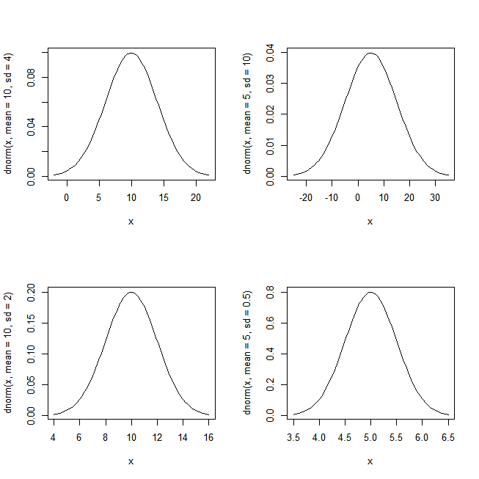

* + Plot the following regions and probabilities in R (use 4 dec. places)

$Y∼N\left(0, 1\right), P\left(Y≥2\right)$

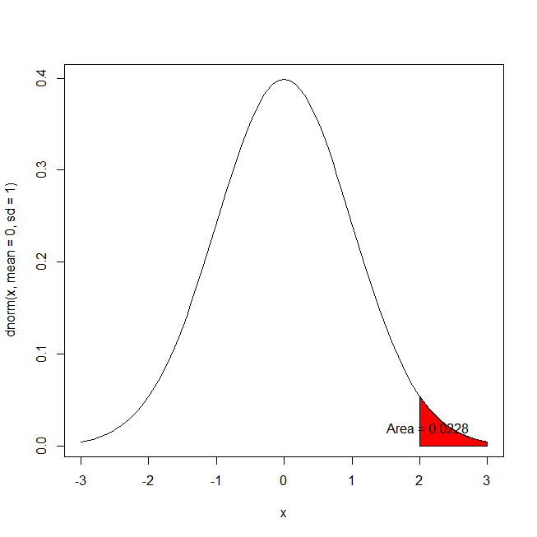

$Y∼N\left(μ=4,σ=2\right), P\left(1≤Y<5\right)$

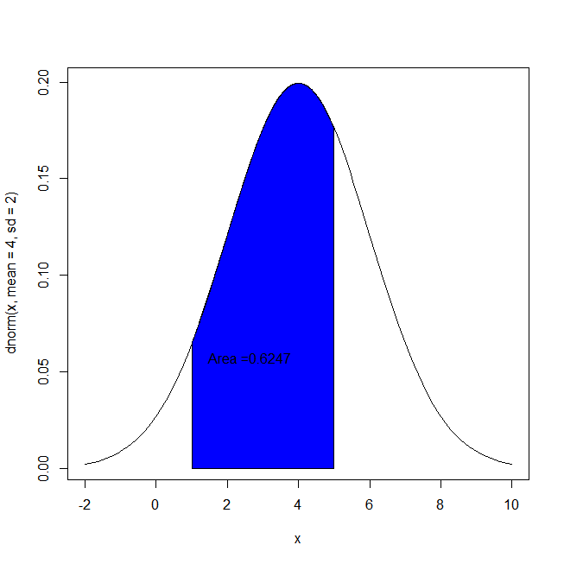

$Y∼N\left(μ=10,σ=4\right), P\left(Y<10\right)$

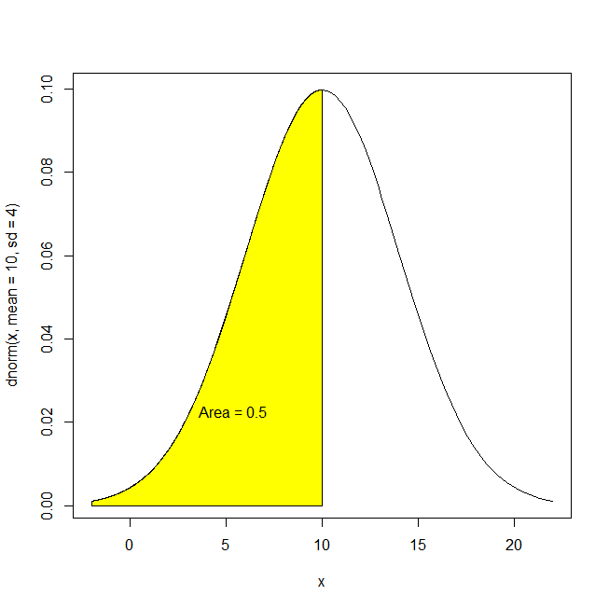

$Y∼N\left(μ=-2,σ=\frac{1}{2}\right), P\left(-3<Y≤ -2\right)$

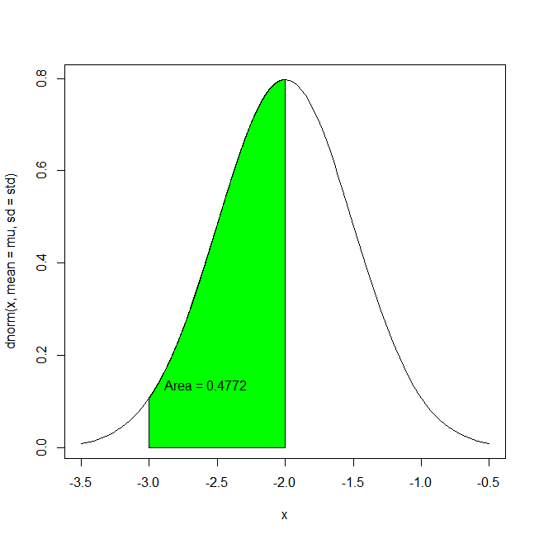

* Task 3
  + We will now study the gamma distribution. This has two parameters, shape (>0) and scale (>0). You will use dgamma() and pgamma()
  + Notice that the random variable Y takes only positive values.
  + On the one plotting surface overlay the following three plots (NB – Don’t use layout)

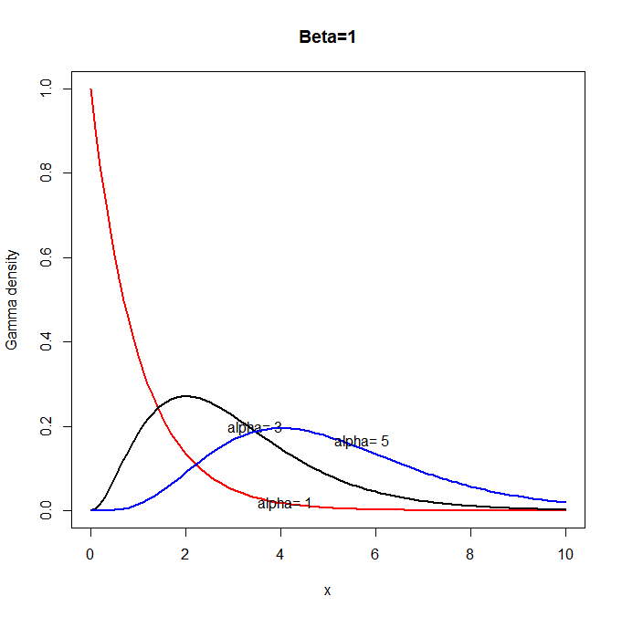

* + Plot the following regions and probabilities in R

$Y\sim Gamma\left(shape=3,scale=2\right), P\left(2<Y<5\right)$

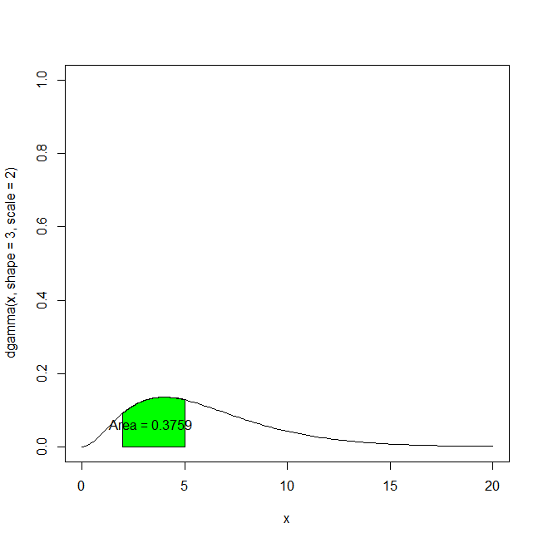

$Y∼Gamma\left(shape=6,scale=3\right), P(1≤Y≤4)$

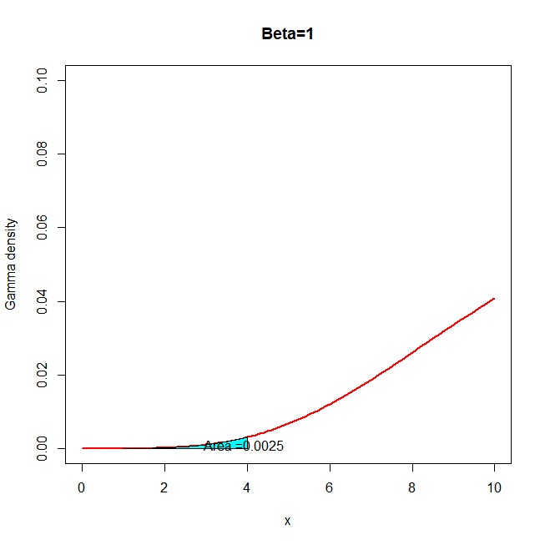

$Y∼Gamma\left(shape=2,scale=4\right), P\left(3≤Y<6\right)$

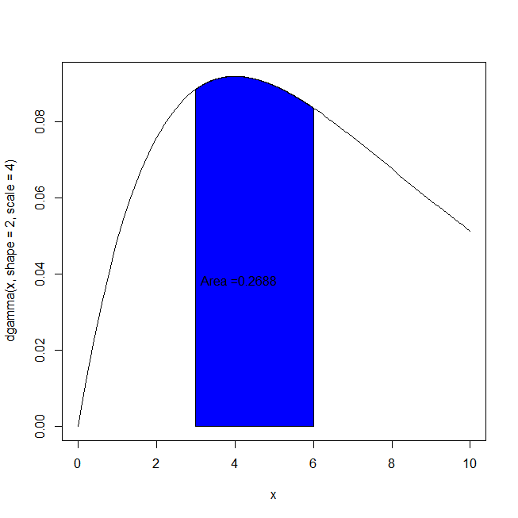

* Task 4
  + The chi-square distribution is a special case of the gamma with shape = $\frac{ν}{2}$ and scale =2, where $ν$ is called the number of degrees of freedom.
  + Use layout() and break up the graphical interface so that there are four squares to plot the following on:

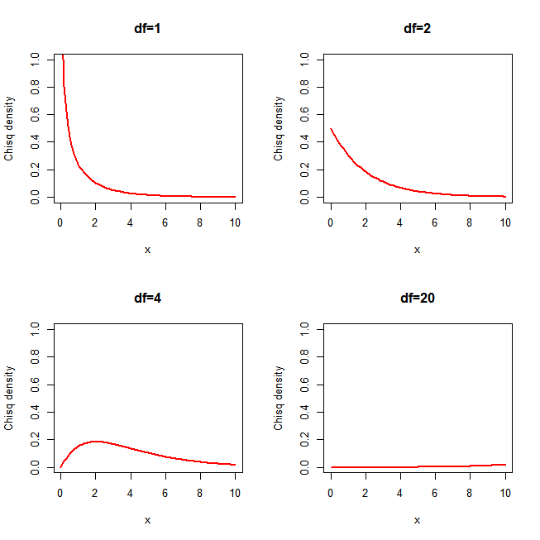

* + Plot the following regions and probabilities in R on separate plotting surfaces.

$Y∼chisq\left(df=2\right), P\left(2≤Y≤4\right)$

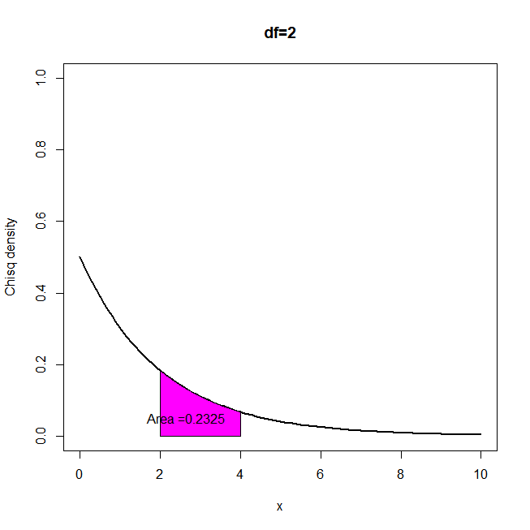

$Y∼chisq\left(df=3\right), P\left(3≤Y≤5\right)$

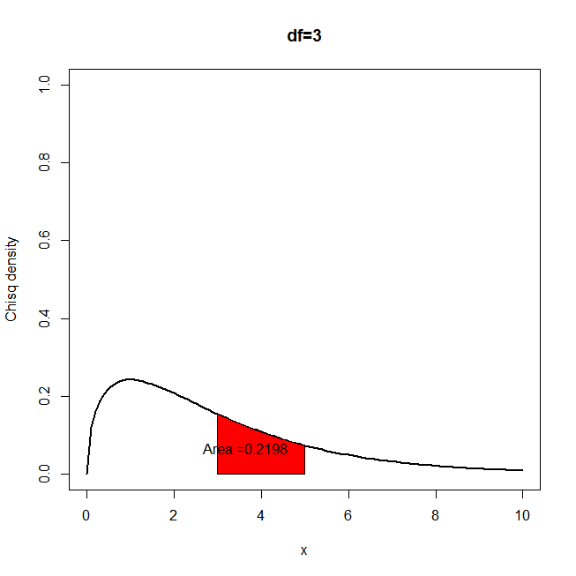



$Y∼chisq\left(df=20\right), P(10<Y≤21)$

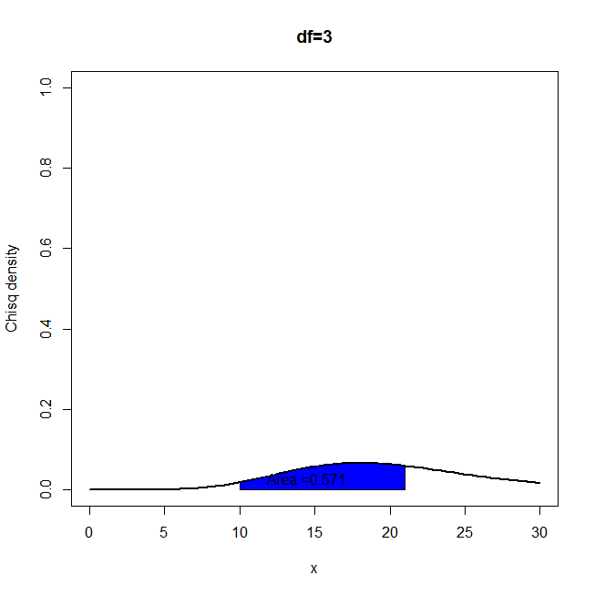

* Task 5
  + The Weibull measures length of life like a gamma. $0≤Y<∞$ and it has two parameters, shape and scale both $>0$.
  + Use dweibull() and pweibull().
  + Make four plots as above with any shape and scale combinations you wish (Using layout()).

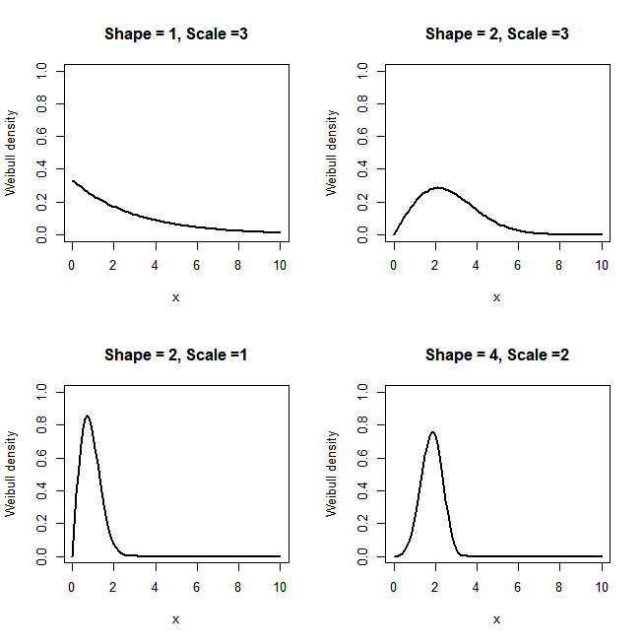

* + Calculate any three areas and probabilities you choose and show them on the graphs as above (separate plots).

P(2<=Y<=4) Y~Weibull(shape =1, scale =3)

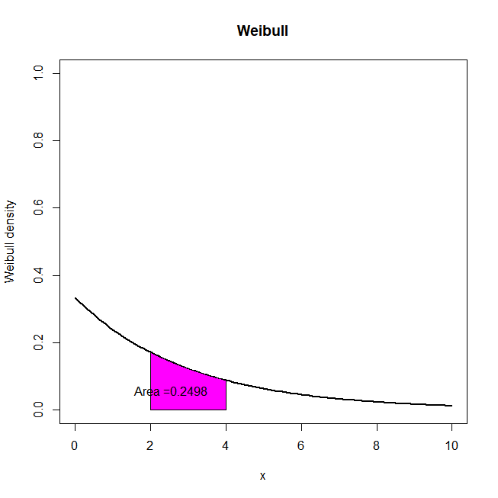

P(1<=Y<=5) Y~Weibull(shape =2, scale =3)

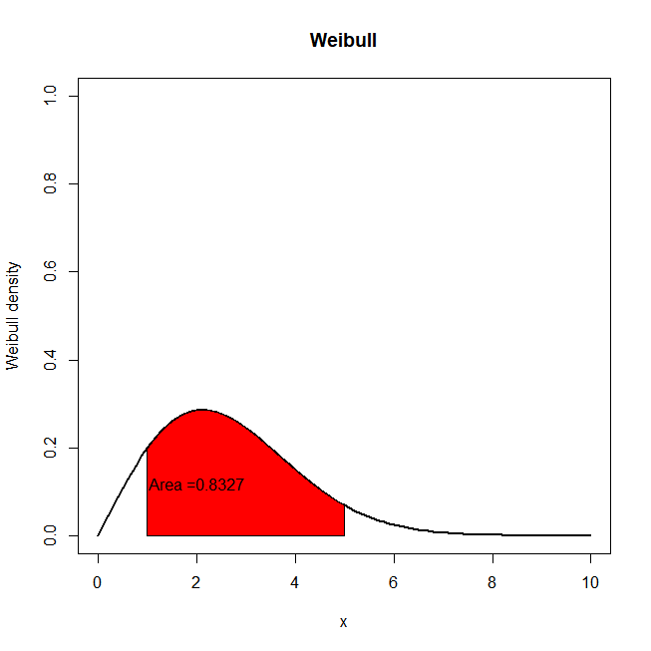

P(2<=Y<=4) Y~Weibull(shape =2, scale =1)

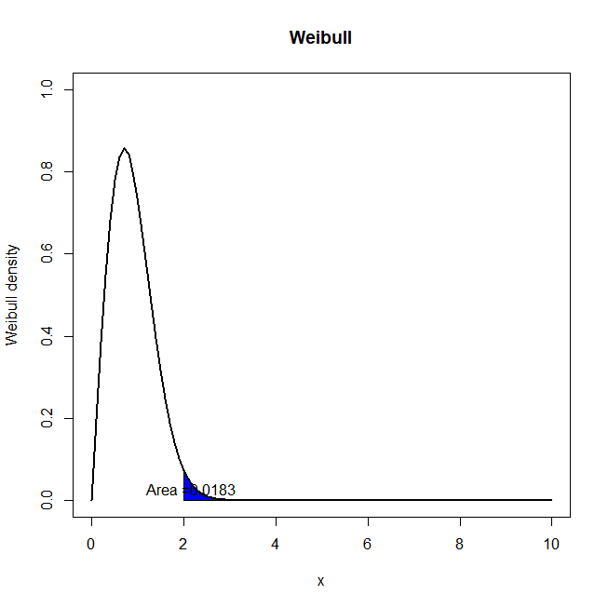

* Task 6
  + Investigate the beta distribution $0≤Y≤1$, it has two parameters.
  + Make sure you understand the parameters by using ?dbeta in R
  + Repeat task 5 for the beta distribution.

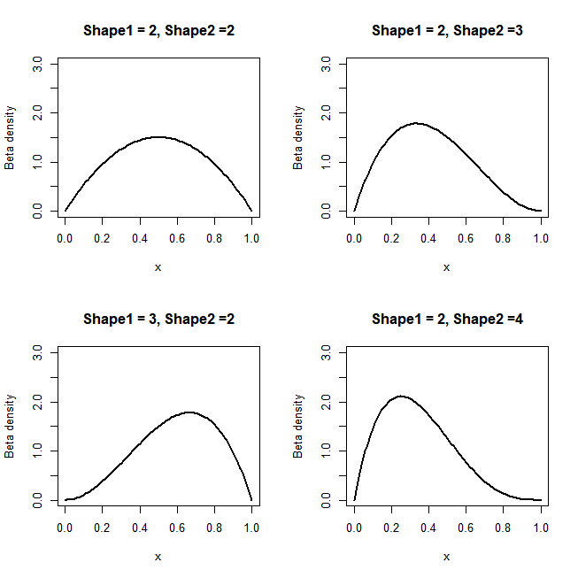

alpha = beta = 2, P(Y>.30)

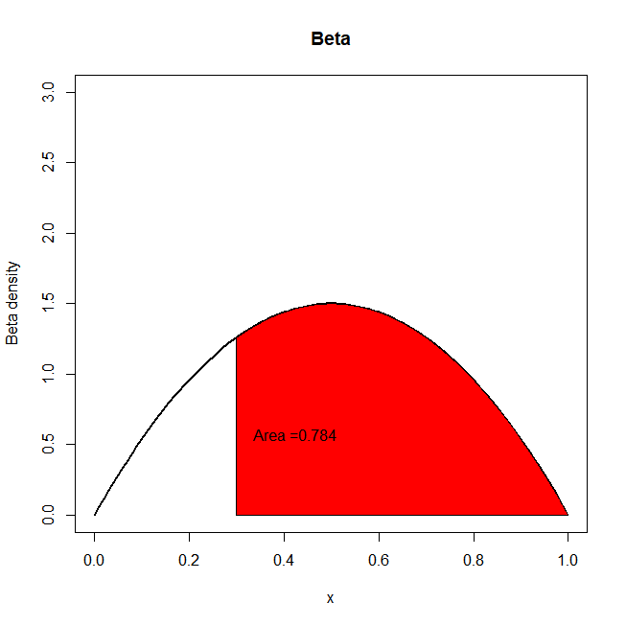

Apha = 3, beta = 2, P(Y<0.2)

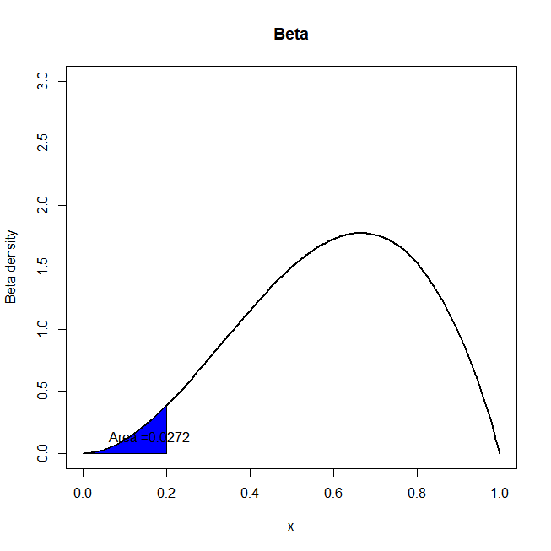

Alpha = 2, beta =4, P(0.2<Y<0.4)

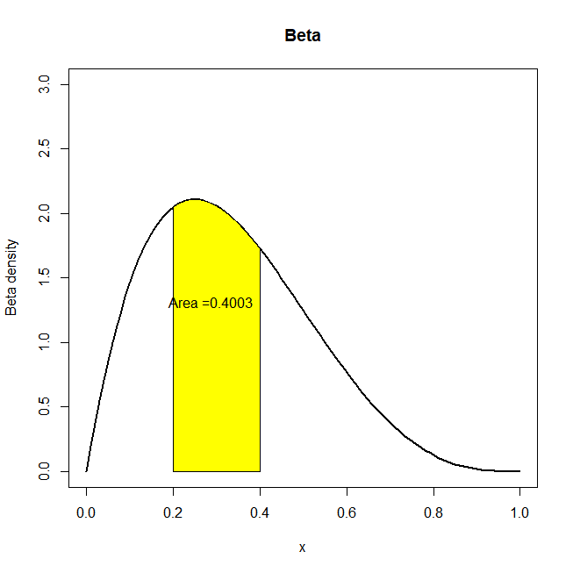

Alpha =3, beta =4, P(0.1<Y<0.9)

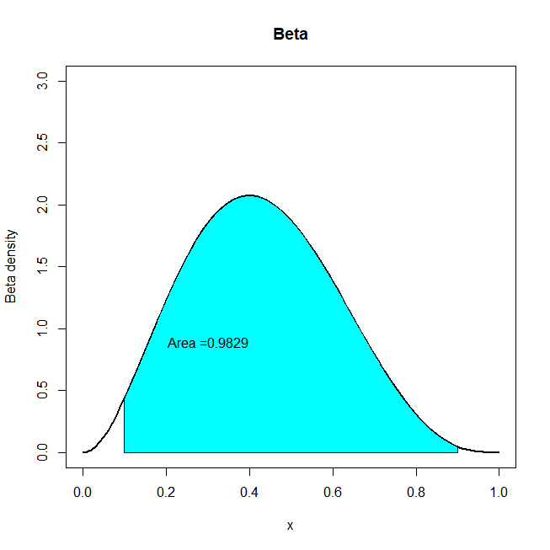

################### LAB FINISHES HERE ###############################

* Task 7 – Extra for experts
  + Write some code that will use the gamma density to produce exponential densities. Check the results by using the built in dexp() function.